**LINE FOLLOWING ROBOT BY ARDUINO**

**PROJECT REPORT**

**Submitted by**

**BHARAT KUMAR R (113214120011)**

**HARISH K (113214120015)**

**MADHUSUTHANAN M (113214120020)**

**RAVICHANDRAN T (113214120034)**

**in the partial fulfilment for award of the degree**

**Of**

**BACHELOR OF ENGINEERING**

**in**

**PRODUCTION ENGINEERING**

**DEPARTMENT OF PRODUCTION ENGINEERING**

**VELAMMAL ENGINEERING COLLEGE, SURAPET**

**ANNA UNIVERSITY, CHENNAI - 600 066**

**BONAFIDE CERTIFICATE**

Certified that this project report titled **“LINE FOLLOWER BY ARDUINO”** is the bonafide work of **Bharat Kumar R (113214120011),Harish k (113214120015), Madhusuthanan M (113214120020**), **RAVICHANDRAN T (113214120034),** who carried out the project work under my supervision. Certified further, that to the best of my knowledge the work reported here in does not form part of any other project report or dissertation on the basis of which a degree or award was conferred on an earlier occasion on this or any other candidate.

**INTERNAL GUIDE,**

**Mr.P.Senthilkumar, M.E.Ph.D**

**Department of Production Engineering,**

**Velammal Engineering College,Chennai-66**

**ABSTRACT**

A line following robot is a robot that basically follows a specific line. This line following robot is sensor based. Sensor based approach uses various kinds of sensors such as IR sensors and ultrasonic sensors. IR sensors are generally used for measuring the difference in reflectivity of surfaces depending on the properties like color, roughness etc. Which is this line follower is based on. The path can be visible like a black line on a white surface (or vice-versa). Sensing a line and maneuvering the robot to stay on course, while constantly correcting wrong moves using feedback mechanism forms a simple yet effective closed loop system.

This bot was developed based on a vision based system to navigate the robot through a black line marked in the white surface. This report is intended to describe the information regarding the project. It explains the requirements, the techniques and technologies used, design and implementation, details, and future improvements of the project.

**CONTENT**

**1.INTRODUCTION -5**

**2.EQUIPMENTS LIST -5**

**3.MICROCONTROLLER -5**

**3.1.SUMMARY -5**

**4.SENSOR -6**

**5.IC L293D DRIVE -7**

**6.CONNECTION -9**

**7.DC MOTOR & BALL CASTER -10**

**8.WORKING PROCEDURE -10**

**9.APPLICATIONS -11**

**10.CONCLUSION -11**

**11.REFERENCE -12**

**1.Introduction**

The line follower is a self operating robot that detects and follows a line that is drawn on the floor. The path consists of a black line on a white surface (or it may be reverse of that). The control system used must sense a line and maneuver the robot to stay on course, while constantly correcting the wrong moves using feedback mechanism, thus forming a simple yet effective closed loop System. The robot is designed to follow very tight curves.

**2.Equipment List**

* Arduino Mega2560.
* IR Sensors
* DC Gear Motor with Wheels.
* DC Power Adapter (9V,2A)
* Ball Castor
* L293D Motor Driver
* Jumper wires

**3.Microcontroller:**

The Arduino Mega 2560 is a microcontroller board based on the ATmega2560 (datasheet). It has 54 digital input/output pins (of which 14 can be used as PWM outputs), 16 analog inputs, 4 UARTs (hardware serial ports), a 16 MHz crystal oscillator, a USB connection, a power jack, an ICSP header, and a reset button. It contains everything needed to support the microcontroller; simply connect it to a computer with a USB cable or power it with a AC-to-DC adapter or battery to get started. The Mega is compatible with most shields designed for the Arduino Duemilanove or Diecimila.

The Mega 2560 is an update to the Arduino Mega, which it replaces.

**3.1.Summary**

Microcontroller ATmega2560

* Operating Voltage 5V
* Input Voltage (recommended) 7-12V
* Input Voltage (limits) 6-20V
* Digital I/O Pins 54 (of which 14 provide PWM output)
* Analog Input Pins 16
* DC Current per I/O Pin 40 mA
* DC Current for 3.3V Pin 50 mA
* Flash Memory 256 KB of which 8 KB used by bootloader
* SRAM 8 KB
* EEPROM 4 KB
* Clock Speed 16 MHz

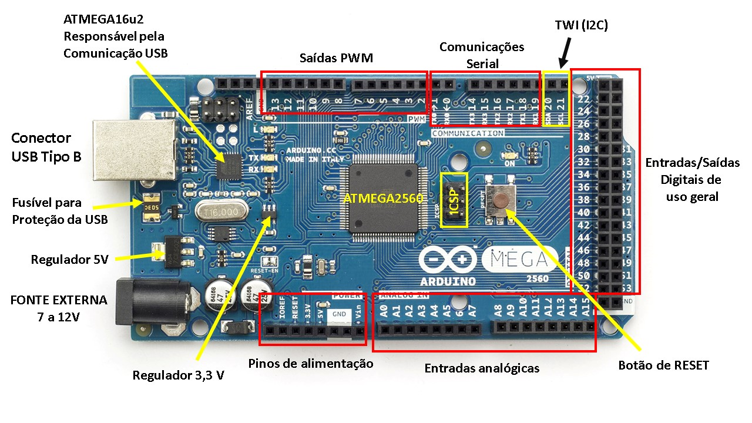

**4.Sensor Circuit:**

For Sensor Circuit we have used a pair of IR Sensors. One is IR LED i.e. transmitter another is an IR Sensor i.e. photoreciever. The basic principle of IR sensor is based on an IR emitter and an IR receiver. IR emitter will emit infrared continuously when power is supplied to it. On the other hand, the IR receiver will be connected and perform the task of a voltage divider. IR receiver can be imagined as a transistor with its base current determined by the intensity of IR light received. The lower the intensity of IR light cause higher resistance between collector-emitter terminals of transistor, and limiting current from collector to emiiter. This change of resistance will further change the voltage at the output of voltage divider. In others word, the greater the intensity of IR light hitting IR receiver, the lower the resistance of IR receiver and hence the output voltage of voltage divider will decreased. Usually the IR emitter and IR receiver will be mounted side by side. Since the output voltage from voltage divider varies with the intensity of IR light pointing to a reflective surface. The further distance away between emitter and receiver decrease the amount of infrared light hitting the receiver if the distance between the sensor and a reflective surface is fixed. Since the output voltage from voltage divider varies with the intensity of IR light we have used analog arduino input to measure the results to make the sensor take the readings.The values of the resistors are calibrated for better reading differences. These voltage differences readings are analog readings. Ardunio has built in ADC which it converts to Digital. When the IR emitter falls on a white surface it gets reflected and the IR receiver receives the full IR intensity thus lower resistance between emitter and collector terminal causing flowing of current and resulting a larger voltage. But when it falls on a black or similar surface IR is absorbed and the receiver receives a lot less IR resulting increase of resistance between the emitter and collector terminal causing limiting of current thus the output voltage. These voltage changes are ranged between (1-1024) as the analog outputs of arduino are 10 bit resolutions. We differentiated the analog values in order to get our required results. We have used 8 sensors in an array for the line detection. The middle sensor will always read black while the other two will read white surface. And it is programmed to move or rotate on basis of readings that it is getting from the readings from the sensor array.

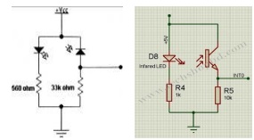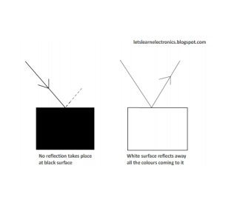

**5.IC L293D Drive motor :**

The most common method to drive DC motors in two directions under control of a computer is with an H-bridge motor driver. H-bridges can be built from scratch with bi-polar junction transistors (BJT) or with field effect transistors (FET), or can be purchased as an integrated unit in a single integrated circuit package such as the L293. The L293 is simplest and inexpensive for low current motors, For high current motors, it is less expensive to build your own H-bridge from scratch. Motor driver is basically a current amplifier which takes a low-current signal from the microcontroller and gives out a proportionally higher current signal which can control and drive a motor. In most cases, a transistor can act as a switch and perform this task which drives the motor in a single direction. Turning a motor ON and OFF requires only one switch to control a single motor in a single direction. But by reversing its polarity motor control in both direction is achievable.

This can be achieved by using four switches that are arranged in an intelligent manner such that the circuit not only drives the motor, but also controls its direction. Out of many, one of the most common and clever design is a H-bridge circuit where transistors are arranged in a shape that resembles the English alphabet "H".

The circuit has four switches A, B, C and D. Turning these switches ON and OFF can drive a motor in different ways. 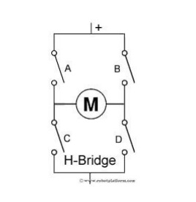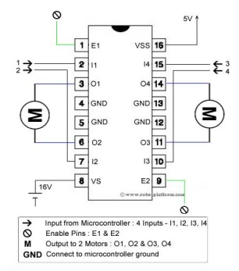

1. Turning on Switches A and D makes the motor rotate clockwise

2. Turning on Switches B and C makes the motor rotate anti-clockwise

3. Turning on Switches A and B will stop the motor (Brakes)

4. Turning off all the switches gives the motor a free wheel drive

5. Lastly turning on A & C at the same time or B & D at the same time shorts your entire circuit. So, do not attempt this.

L293D IC generally comes as a standard 16-pin DIP (dual-in line package). This motor driver IC can simultaneously control two small motors in either direction; forward and reverse with just 4 microcontroller pins.

**6.Connections:**

The circuit shown to the right is the most basic implementation of L293D IC. There are 16 pins sticking out of this IC and we have to understand the functionality of each pin before implementing this in a circuit.

1. Pin1 and Pin9 are "Enable" pins. They should be connected to +5V for the drivers to function. If they pulled low (GND), then the outputs will be turned off regardless of the input states, stopping the motors. If you have two spare pins in your microcontroller, connect these pins to the microcontroller, or just connect them to regulated positive 5 Volts.

2. Pin4, Pin5, Pin12 and Pin13 are ground pins which should ideally be connected to microcontroller's ground.

3. Pin2, Pin7, Pin10 and Pin15 are logic input pins. These are control pins which should be connected to microcontroller pins. Pin2 and Pin7 control the first motor (left); Pin10 and Pin15 control the second motor(right).

4. Pin3, Pin6, Pin11, and Pin14 are output pins. Tie Pin3 and Pin6 to the first motor, Pin11 and Pin14 to second motor

5. Pin16 powers the IC and it should be connected to regulated +5Volts 6. Pin8 powers the two motors and should be connected to positive lead of a secondary battery. As per the datasheet, supply voltage can be as high as 36 Volts.

**7.DC Motor with Wheels & Ball Caster:**

**Motor Specifications**

**Operating voltage:** 3V ~ 6V DC (recommended value 5V)

**Maximum torque:** 800g.cm

**Speed without load:** 90±10rpm

**Reduction ratio:** 1:48

**No Load current:** 190mA (max.250mA)

**8.Working Procedure**

With the supply from an 9V DC power adapter the whole sensor and the motor driver IC and the motors and arduino are powered. Making the setup less prone to power failures. With the help of IC7805 a regulate 5V is supplied to the sensor circuits and same 5V is supplied to the enables of motor driver IC L293D. The outputs of the sensor circuits are connected as in the analog inputs of the arduino board. The motor driver IC inputs are taken from four arduino digital PWM pins and the outputs are connected to the motors. Taking analog based (1-1024) readings from the sensors the arduino is programmed to control the motor based on the readings.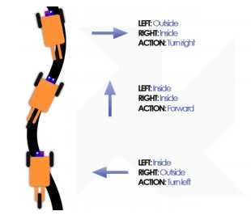

**9.Applications**

This line following robotics has various types of applications in both home and industrial sectors.

* Industrial Applications: These robots can be used as automated equipment carriers in industries replacing traditional conveyer belts.
* Automobile applications: These robots can also be used as automatic cars running on roads with embedded magnets.
* Domestic applications: These can also be used at homes for domestic purposes like floor cleaning etc.
* Guidance applications: These can be used in public places like shopping malls, museums etc to provide path guidance.

Besides there will be much more applications which we do not know now but can be done this type of robots.

**10.Conclusion**

The line following robot project challenged the group to cooperate, communicate, and expand understanding of electronics, mechanical systems, and their integration with programming. This project would not have been successful without every member of the group contributing and communicating during the problem-solving process,and without the knowledge and advice of Mr.P.Senthilkumar. Overall, the line following robot was an incredible learning opportunity for everyone involved.

**11.Refernce**

[1] http://robotsreloaded.blogspot.com/p/line-following-robot-without.html

[2] http://www.roboticsbible.com/simple-line-following-robot.html

[3] http://abhitechstrong.blogspot.com/2013/01/robotproject-1-making-line-follower.html

[4 ]http://legendtronics.blogspot.com/2013/10/linefollower-robot-with-and-without.html

[5] http://www.elprocus.com/line-follower-robot basics-controlling/

[6] http://embedded-electronics.blogspot.com/2013/06/line-follower-robot-without.html

[7] http://circuit-diagram.hqew.net/Analog-Line-Follower-Robot_11907.html

[8] http://letslearnelectronics.blogspot.com/2012/08/me-line-follower-robot-from-basics.html

[9] http://letslearnelectronics.blogspot.in/2012/06/plag-with-sensors-making-decision.html

[10] http://www.techshopbd.com/tutorial-categories/robotics/line-following-robot